📘 FINAL PROJECT REPORT
SentinelShield – Hybrid Intrusion Detection and Web Protection System

Title Page
Project Title:
SentinelShield – Hybrid Intrusion Detection and Web Protection System

Abstract
This project presents the design and implementation of SentinelShield, a hybrid intrusion detection and web protection system developed to analyze HTTP traffic in real time. The system inspects incoming requests, applies signature-based and behavior-based detection techniques, correlates multiple security signals, logs security events, and visualizes the results through a web-based dashboard. SentinelShield demonstrates how modern web security systems operate and provides practical exposure to web attack detection, log analysis, and security monitoring concepts.

1. Introduction
Web applications are critical components of modern information systems and are frequent targets of cyber attacks such as SQL Injection, Cross-Site Scripting (XSS), and command injection. Traditional security measures like input validation alone are often insufficient to defend against sophisticated attacks. Therefore, security systems must inspect requests, identify malicious patterns, and respond in real time.
SentinelShield is developed as a learning-oriented security framework that simulates the behavior of a Web Application Firewall (WAF) combined with an Intrusion Detection System (IDS). The project helps students understand how HTTP requests are analyzed, how attacks are detected, and how security events are monitored.

2. Problem Statement
Web applications are vulnerable to multiple forms of attacks that can compromise data confidentiality, integrity, and availability. There is a need for a system that can:
- Inspect incoming HTTP requests
- Detect known attack patterns
- Identify abnormal behavior
- Log security incidents
- Provide visibility through a dashboard
SentinelShield addresses this problem by providing a hybrid detection and monitoring solution.

3. Objectives
The main objectives of this project are:
- To understand the structure of HTTP requests
- To implement signature-based attack detection
- To implement behavior-based anomaly detection
- To combine multiple detection results using correlation scoring
- To log security events in structured format
- To display security information using a dashboard

4. Scope of the Project
The project focuses on detecting web-based attacks at the application layer. It does not aim to replace enterprise security solutions but serves as a practical demonstration of core security concepts such as inspection, detection, logging, and visualization.

5. System Architecture
SentinelShield consists of the following major components:
- Client (Browser / curl)
- WAF Gateway
- Detection Engine
- Logging System
- Dashboard Interface
- Backend Web Application
The WAF Gateway sits between the client and the backend application and inspects every request before forwarding it.
Architecture Flow:
Client → WAF Gateway → Backend Application
↓
Logs → Dashboard

- Architecture Diagram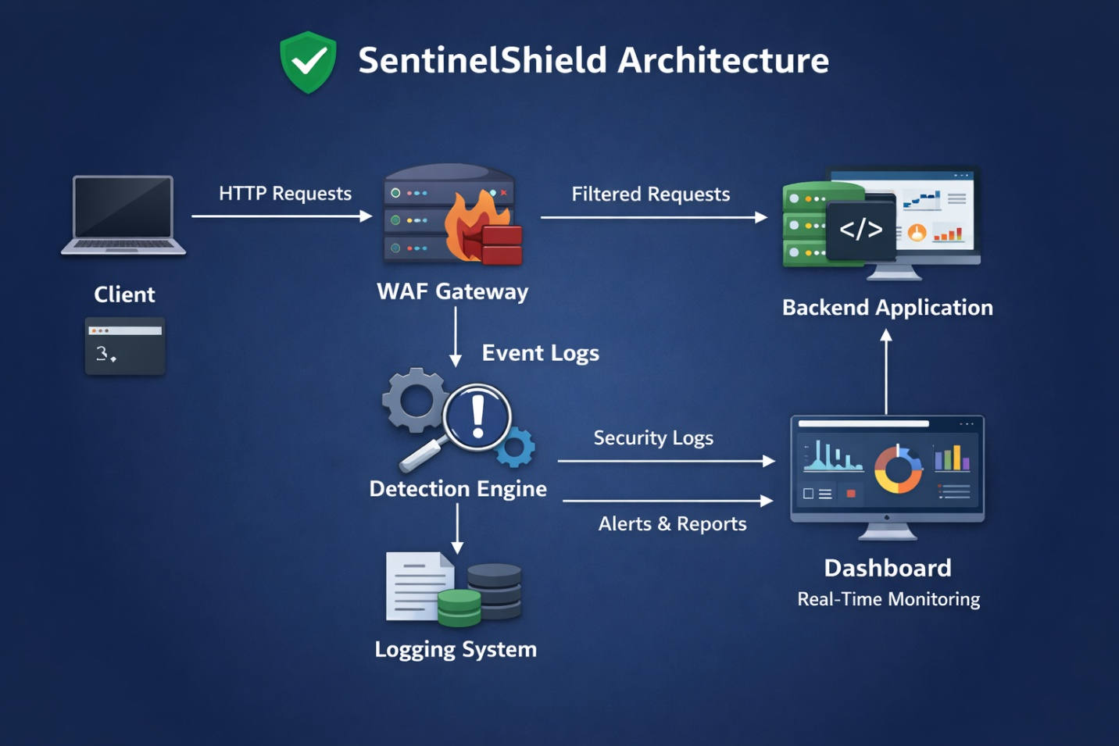

6. Technologies Used
- Python – Core backend logic
- Flask – Web server and API framework
- JavaScript – Frontend logic
- React (Vite) – Dashboard UI
- Node.js & npm – Frontend runtime
- curl – Request testing tool
- Linux OS – Development environment

7. System Design
7.1 HTTP Request Inspection
The system extracts important parts of each request such as path, query parameters, headers, and body. The extracted data is normalized before analysis.
7.2 Signature-Based Detection
Predefined attack patterns are stored and matched against request content to detect known attacks.
7.3 Behavior-Based Detection
The system monitors request frequency, repeated failures, and unusual patterns to detect suspicious behavior.
7.4 Correlation Scoring
Results from different detectors are combined into a single risk score.
7.5 Decision Engine
Based on the score, the system decides whether to allow, log, or block the request.
7.6 Logging System
All events are recorded in structured JSON format.
7.7 Dashboard
The dashboard displays statistics and recent security events.

8. Implementation Details
8.1 Backend Application
A simple web application that represents a protected server.
8.2 WAF Gateway
Receives requests, applies detection logic, and forwards clean requests.
8.3 Detection Engine
Combines signature, behavior, and heuristic detectors.
8.4 Dashboard Interface
Fetches logs through APIs and displays them visually.

9. Experimental Setup
Step 1: Start Application
Command: ./run.sh

- Services Running
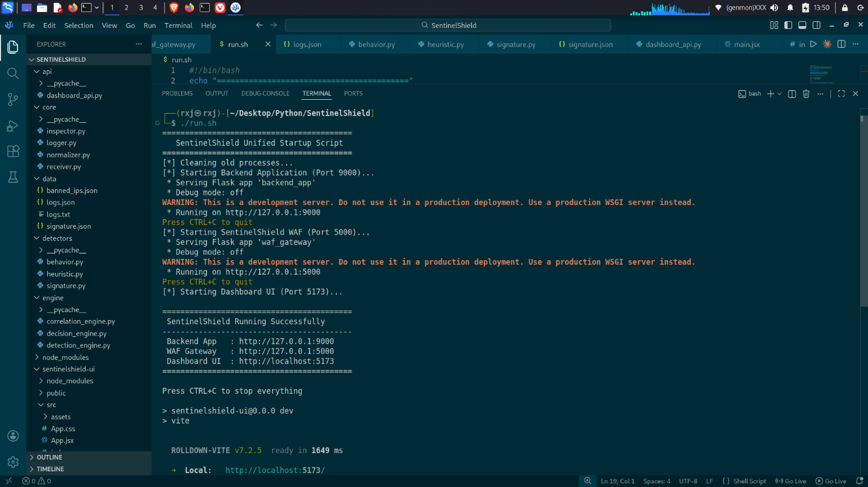

10. Test Cases
No | Attack Type | Payload | Expected Result | Actual Result
1 | Normal | /login | Allowed | Allowed
2 | SQL Injection | admin' OR 1=1 | Blocked | Blocked
3 | XSS | <script>alert(1)</script> | Blocked | Blocked
4 | Brute Force | repeated login | Logged | Logged

11. Results
- Normal requests were processed successfully.
- Malicious requests were detected correctly.
- High-risk attacks were blocked.
- Logs were generated for each request.
- Dashboard updated automatically.

- Logs File
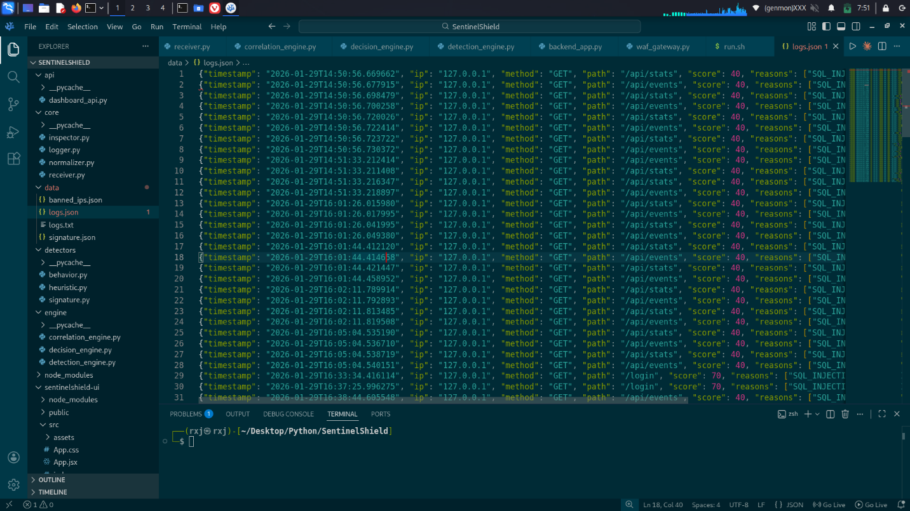

- Dashboard View
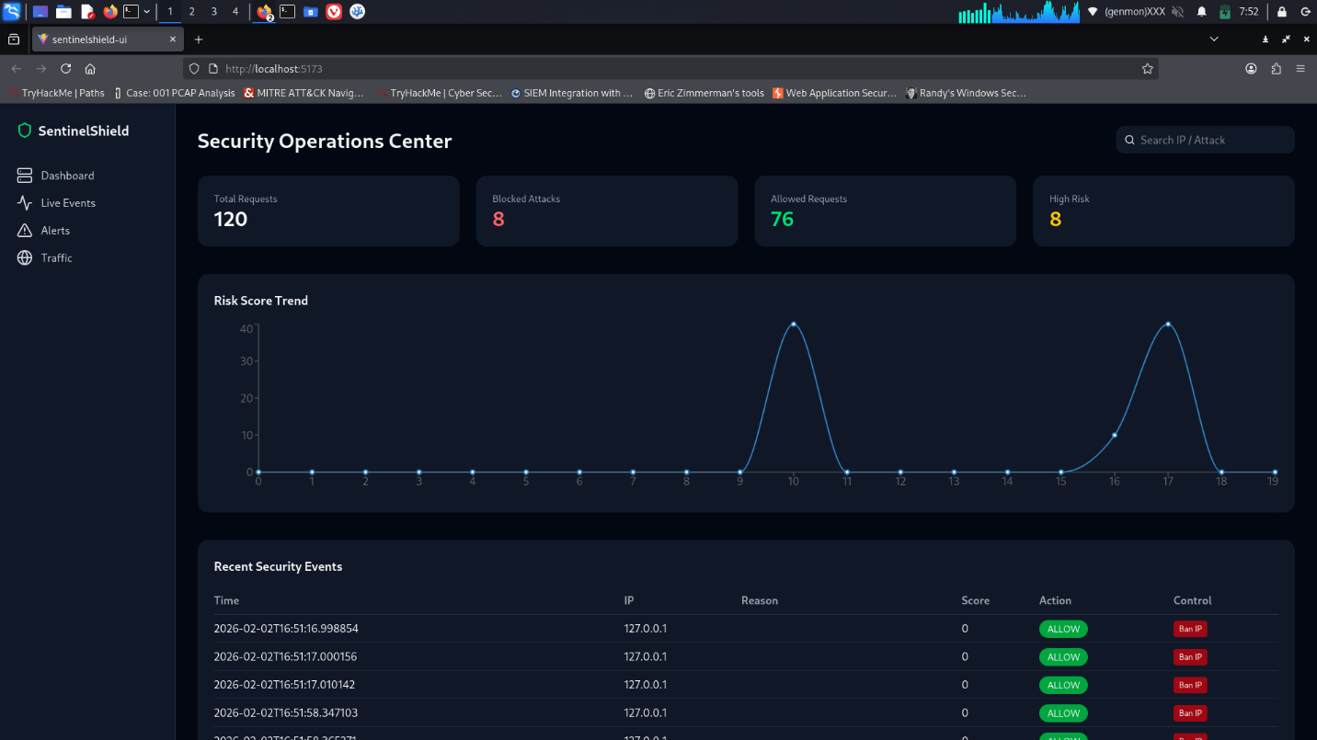

12. Log Analysis
Each log entry contains timestamp, IP address, request path, detection reasons, risk score, and action. Logs help identify repeated attacks and suspicious IP addresses.

13. Dashboard Analysis
The dashboard provides a summary of system activity and helps security analysts understand current security posture.

14. Discussion
Combining multiple detection techniques improves detection accuracy and reduces false positives. Correlation scoring allows the system to prioritize serious threats.

15. Limitations
- No machine learning detection
- No encryption
- Single-node deployment

16. Future Enhancements
- Machine learning-based anomaly detection
- Database logging
- Auto IP banning
- User authentication
- Rule management interface

17. Conclusion
SentinelShield demonstrates the core concepts of web attack detection, logging, and monitoring. The project provides practical experience with modern web security mechanisms.

18. References
- OWASP Top 10
- Flask Documentation
- React Documentation

